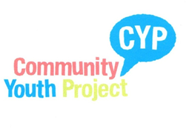
HAMDONS YOUTH GROUP
Thursdays 7:00pm-9:00pm @ Methodist Church Hall Stoke
Years 7 and above

9th January Welcome Back

16th January Pizza Making

23rd January Arts and Crafts

30th January Quiz

6th February Open Session

13th February Valentines Cards

20th February Closed half term

For more information please contact
Lou Chant on 07402 987921 or
email lou.chant@cyp.me.uk
@ Hamdons Youth Group

